MODULE 1:

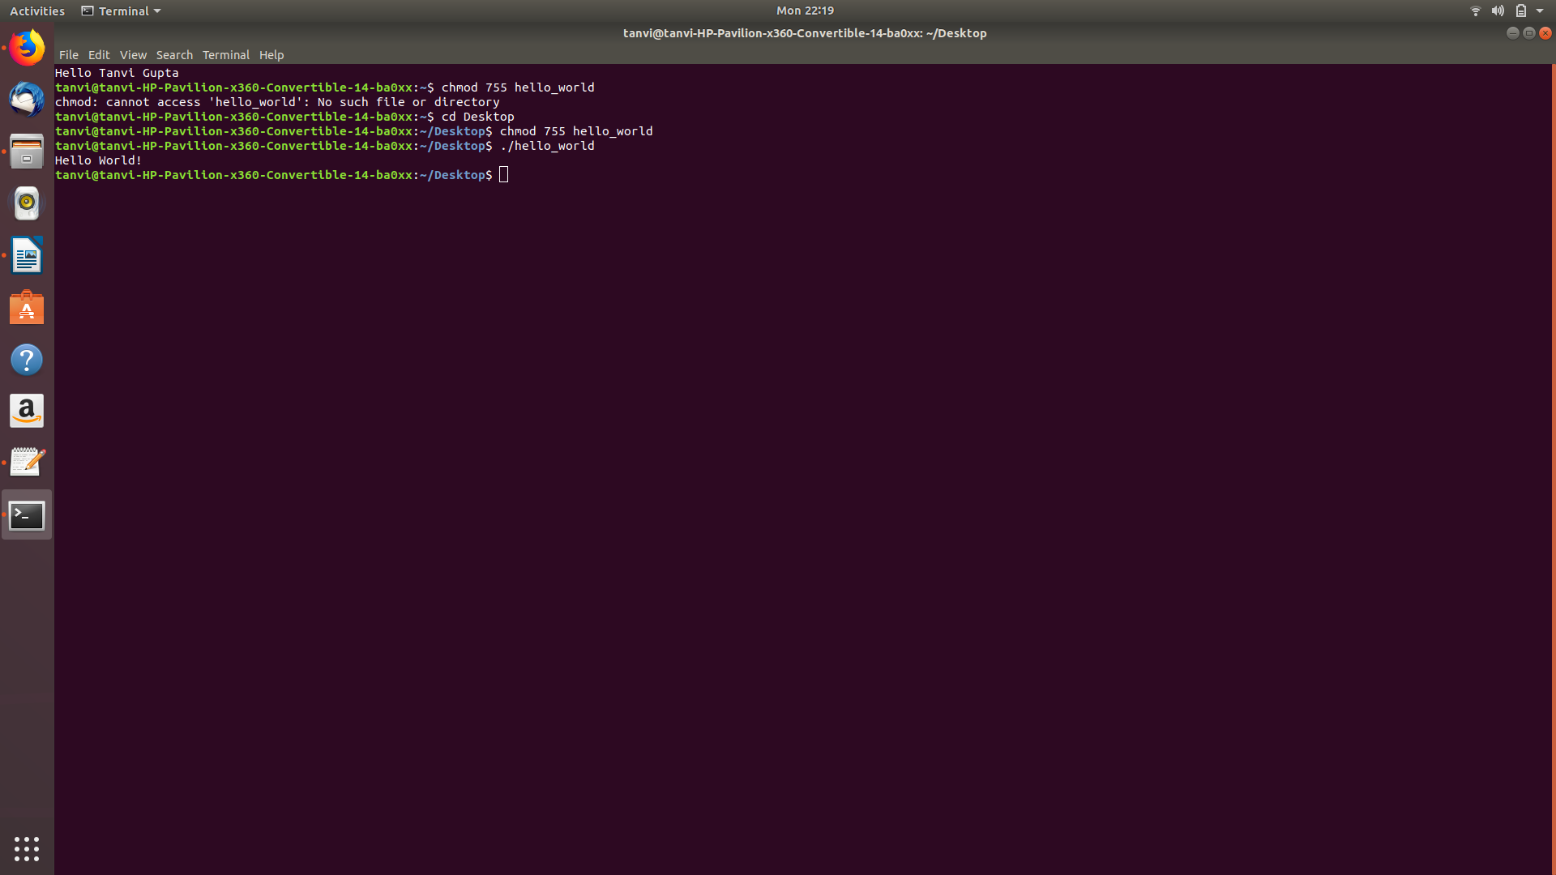

MODULE 2:

Using alias names
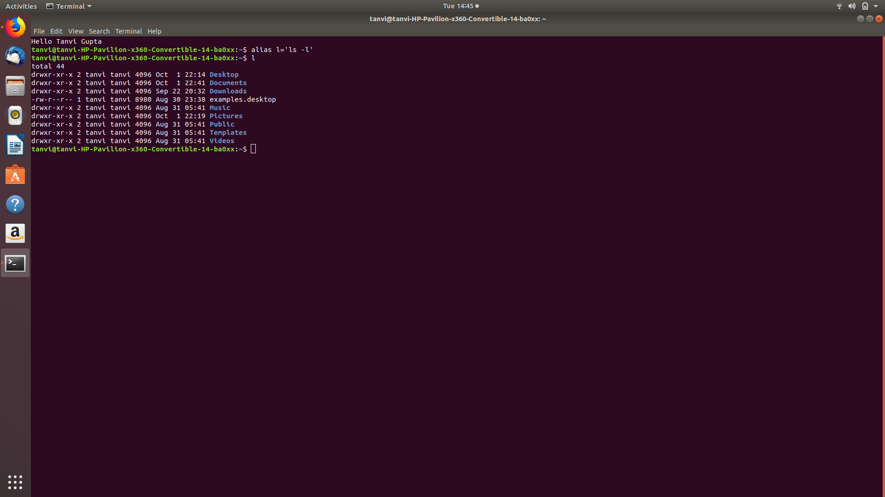

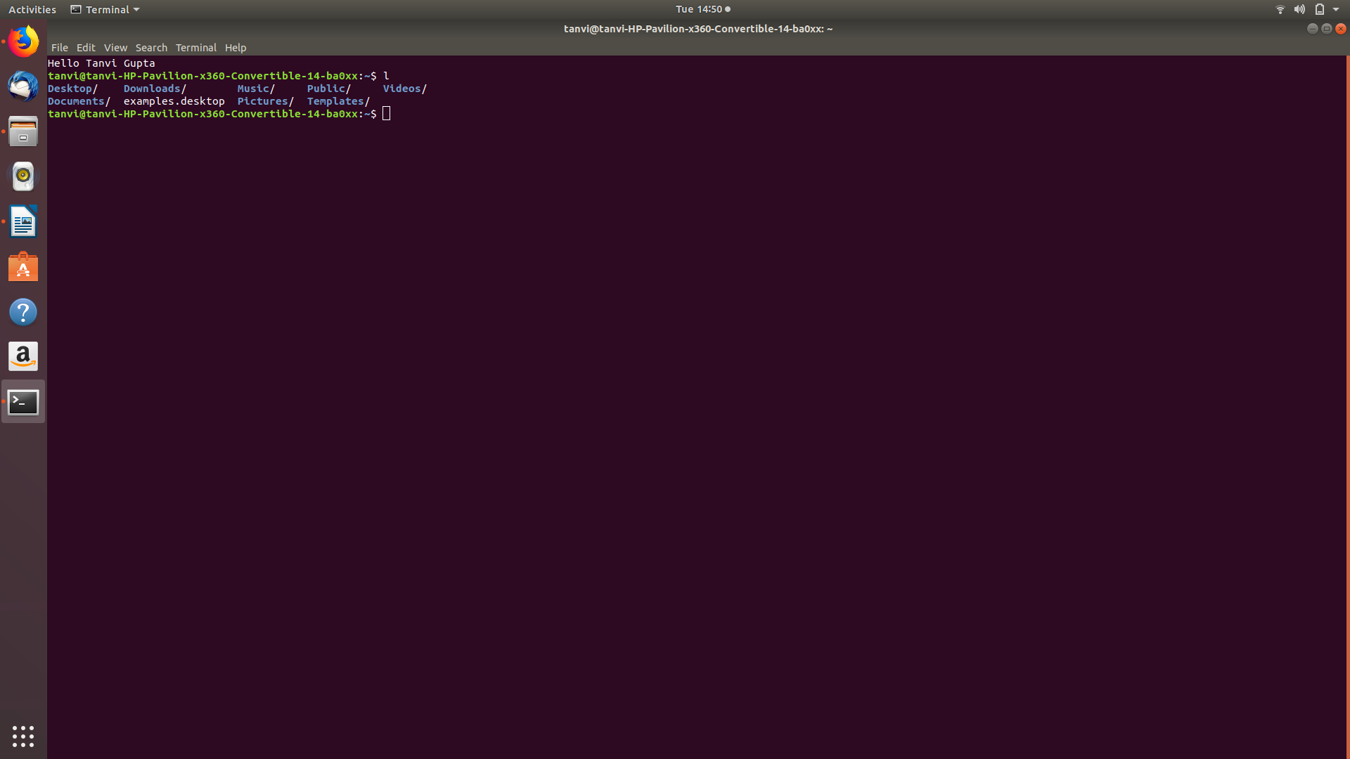

Using shell functions:

MODULE 3-MODULE 8(SUR_19)

MODULE 9:

Creating trouble.bash file

#!/bin/bash

number=1

if [ $number = "1" ]; then
echo "Number equals 1"
else
echo "Number does not equal 1"
fi

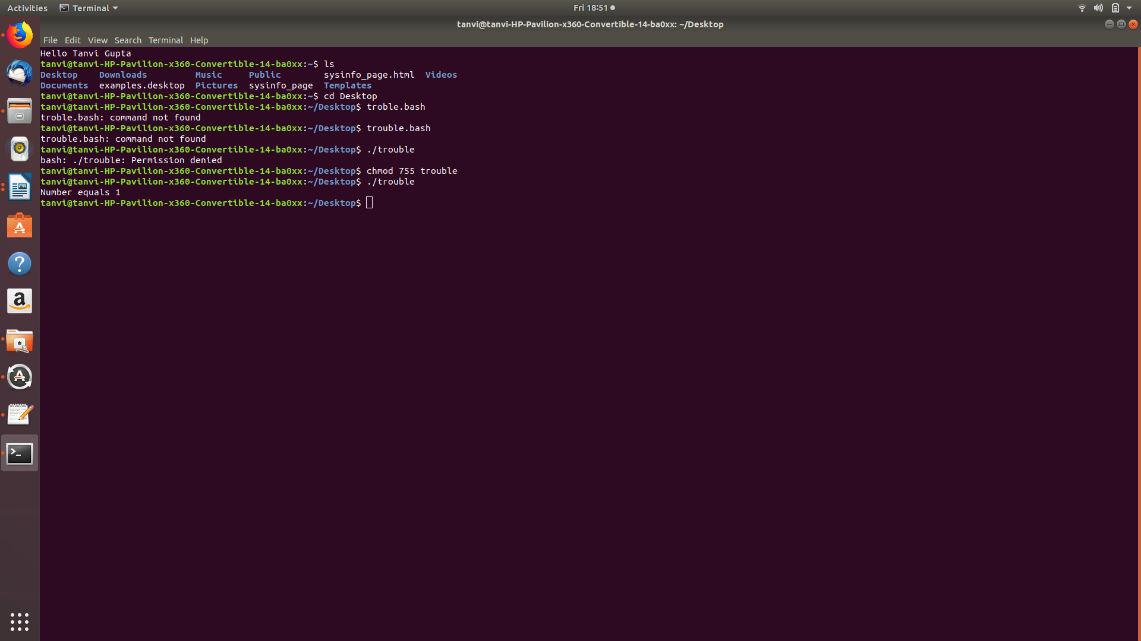

#!/bin/bash

number=

if [ $number = "1" ]; then
echo "Number equals 1"
else
echo "Number does not equal 1"
fi

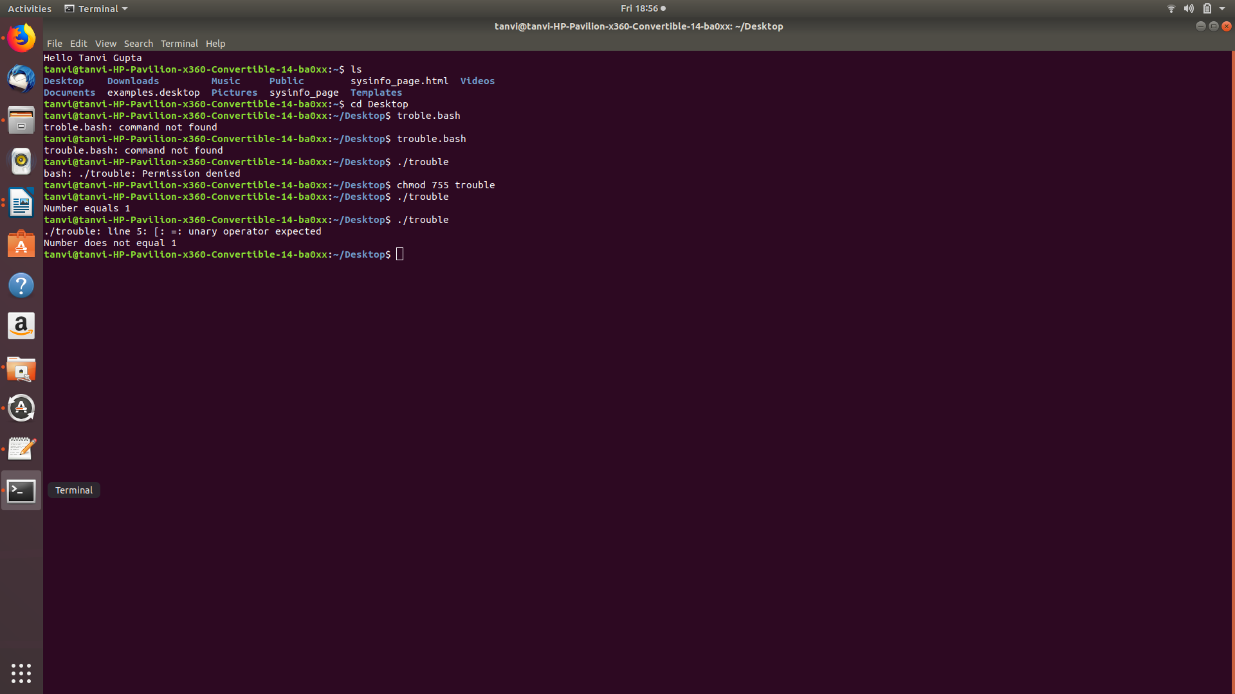

Missing quotes

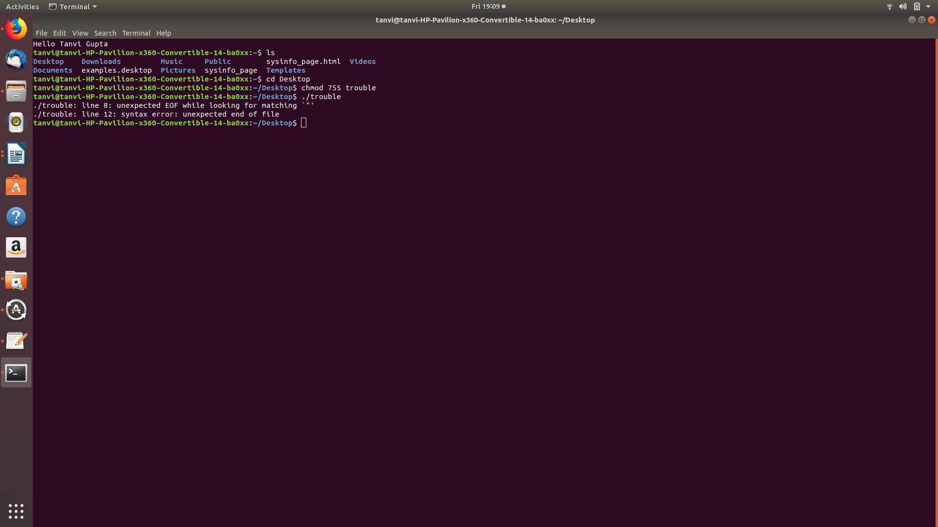

Tracing the scripts

#!/bin/bash -x

number=1

if [ $number = "1" ]; then
echo "Number equals 1"
else
echo "Number does not equal 1"
fi

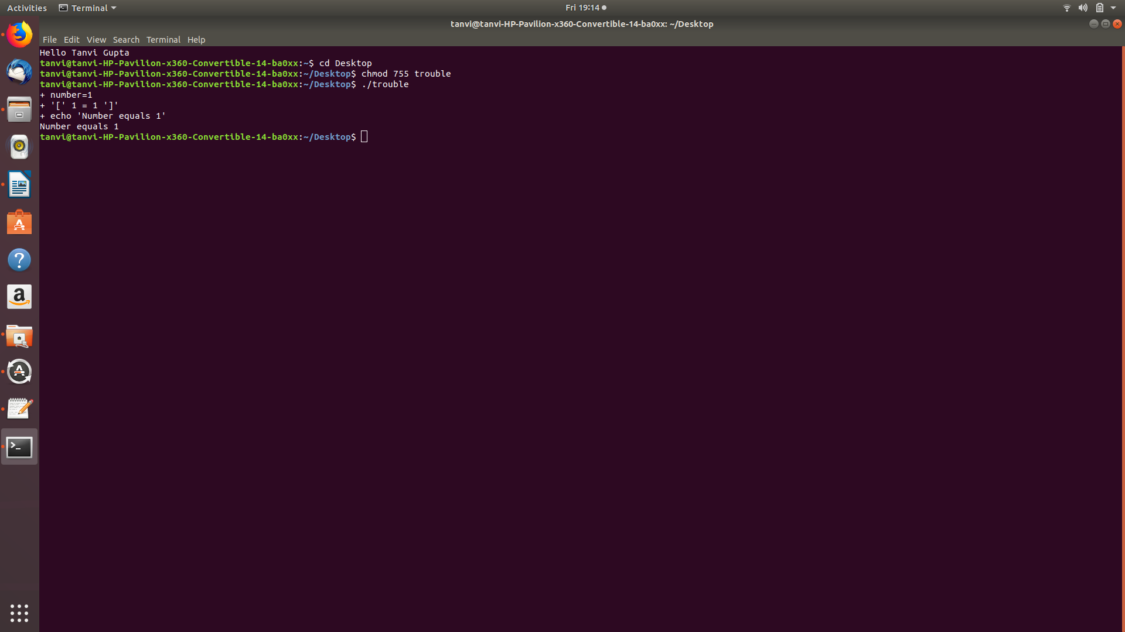

Alternative method:setting offset

#!/bin/bash

number=1

set -x
if [ $number = "1" ]; then
echo "Number equals 1"
else
echo "Number does not equal 1"
fi
set +x
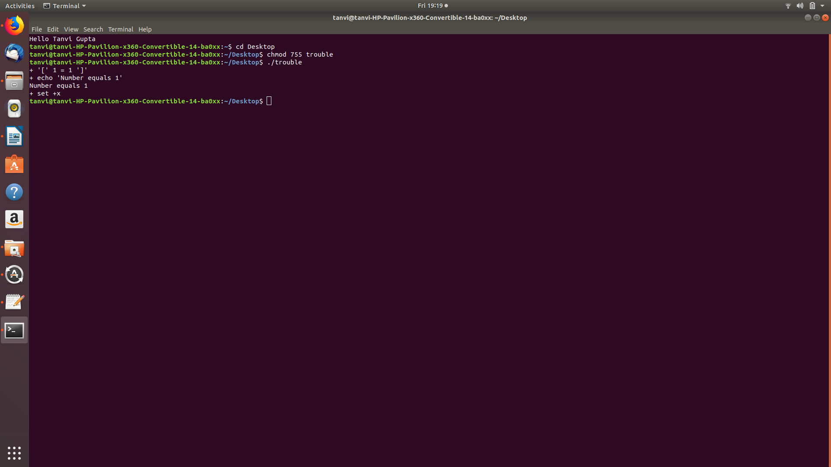

MODULE 10: Keyboard Input And Arithmetic

Taking input in the bash file

#!/bin/bash

echo -n "Enter some text > "
read text
echo "You entered: $text"

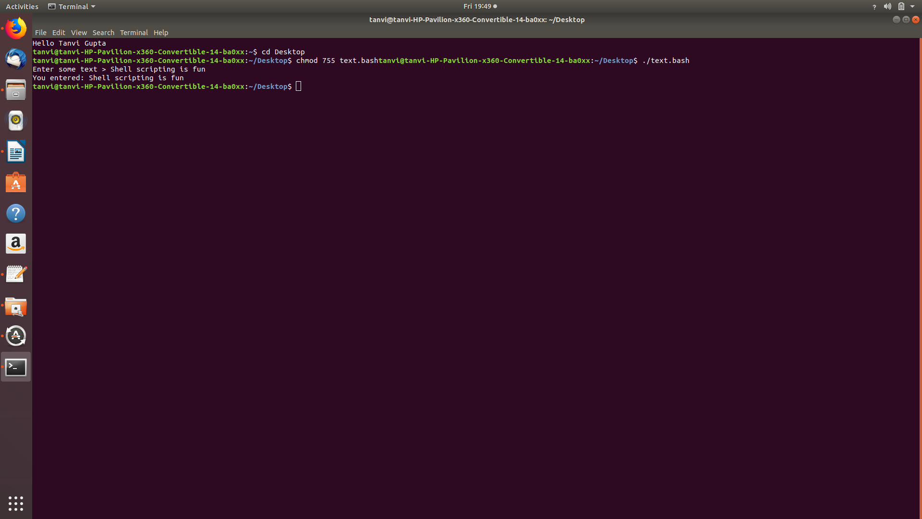
Arithmetic

#!/bin/bash

first_num=0
second_num=0

echo -n "Enter the first number --> "
read first_num
echo -n "Enter the second number -> "
read second_num

echo "first number + second number = $((first_num + second_num))"
echo "first number - second number = $((first_num - second_num))"
echo "first number * second number = $((first_num * second_num))"
echo "first number / second number = $((first_num / second_num))"
echo "first number % second number = $((first_num % second_num))"
echo "first number raised to the"
echo "power of the second number = $((first_num ** second_num))"

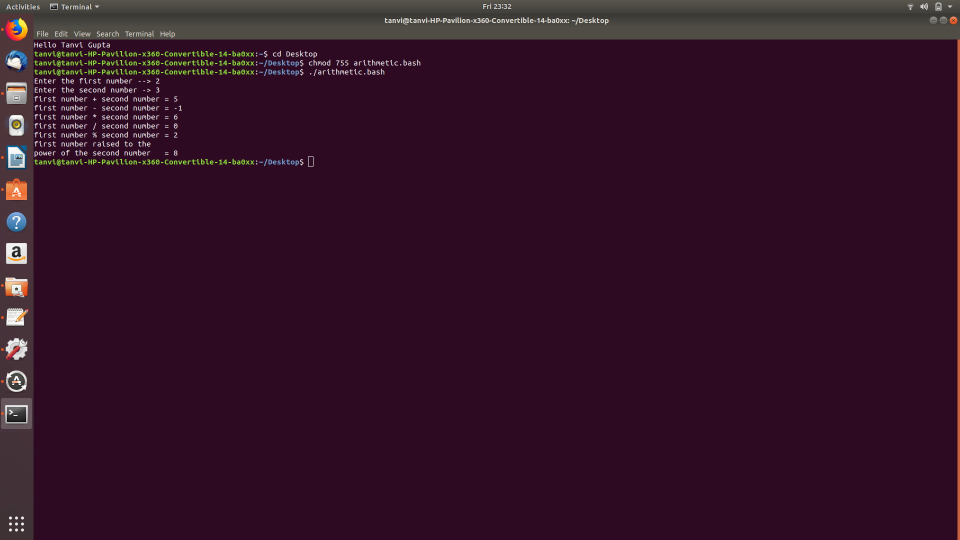

MODULE 11:Flow Control part-2

Branching with if and else

The traditional method:
#!/bin/bash

echo -n "Enter a number between 1 and 3 inclusive > "
read character
if [ "$character" = "1" ]; then
echo "You entered one."
elif [ "$character" = "2" ]; then
echo "You entered two."
elif [ "$character" = "3" ]; then
echo "You entered three."
else
echo "You did not enter a number between 1 and 3."
fi

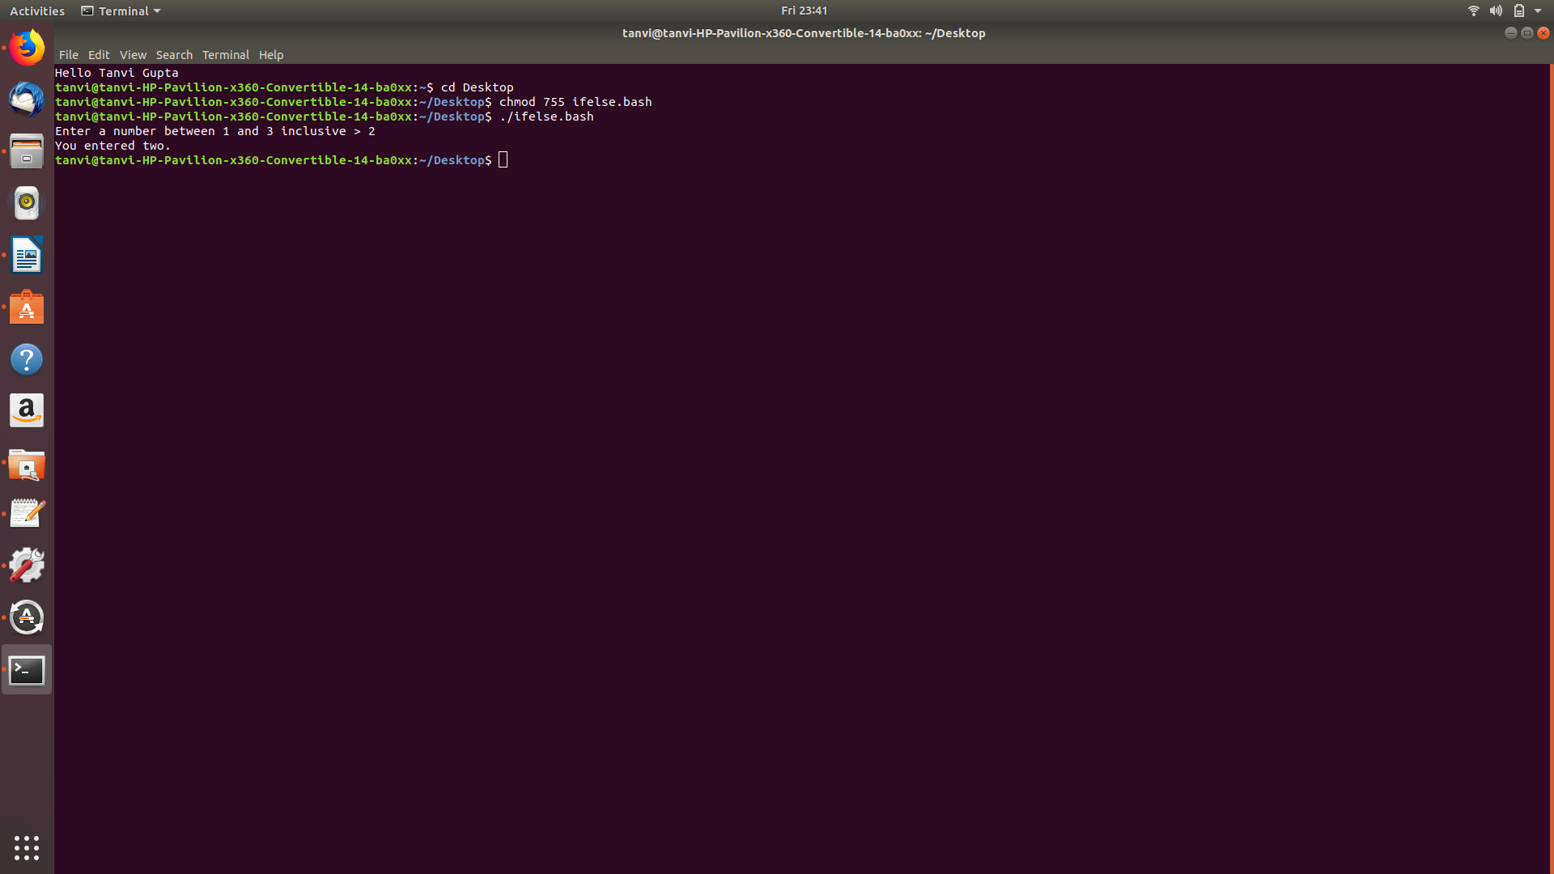

The shell provides an elegant method of using case:

#!/bin/bash

echo -n "Enter a number between 1 and 3 inclusive > "
read character
case $character in
1 ) echo "You entered one."
;;
2 ) echo "You entered two."
;;
3 ) echo "You entered three."
;;
* ) echo "You did not enter a number between 1 and 3."
esac

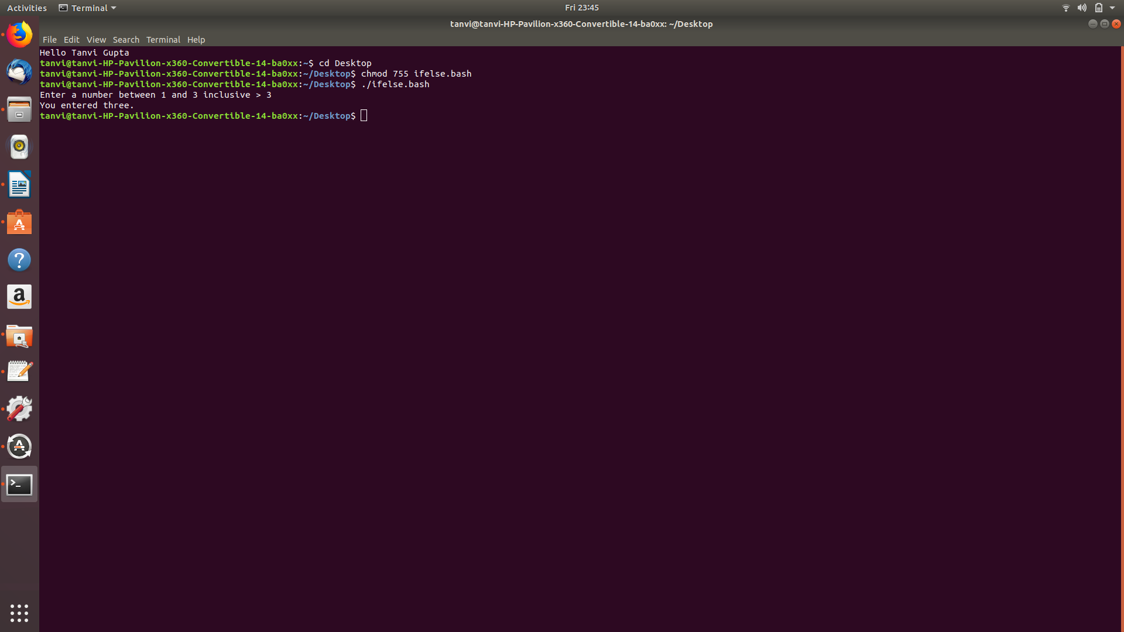

Loops

1.while loop

#!/bin/bash

number=0
while [ "$number" -lt 10 ]; do
echo "Number = $number"
number=$((number + 1))
done

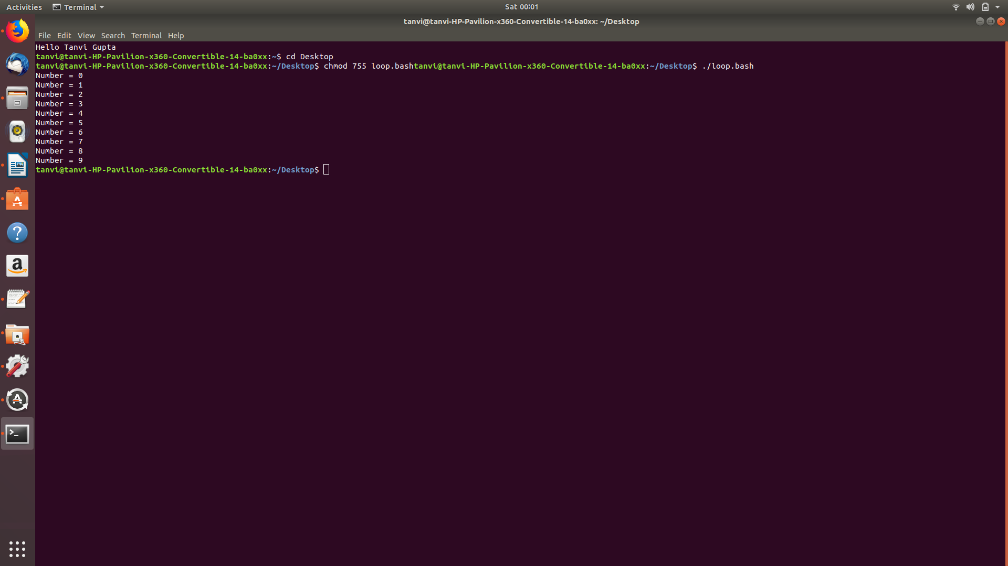

2.Until loop

#!/bin/bash

number=0
until [ "$number" -ge 10 ]; do
echo "Number = $number"
number=$((number + 1))
done

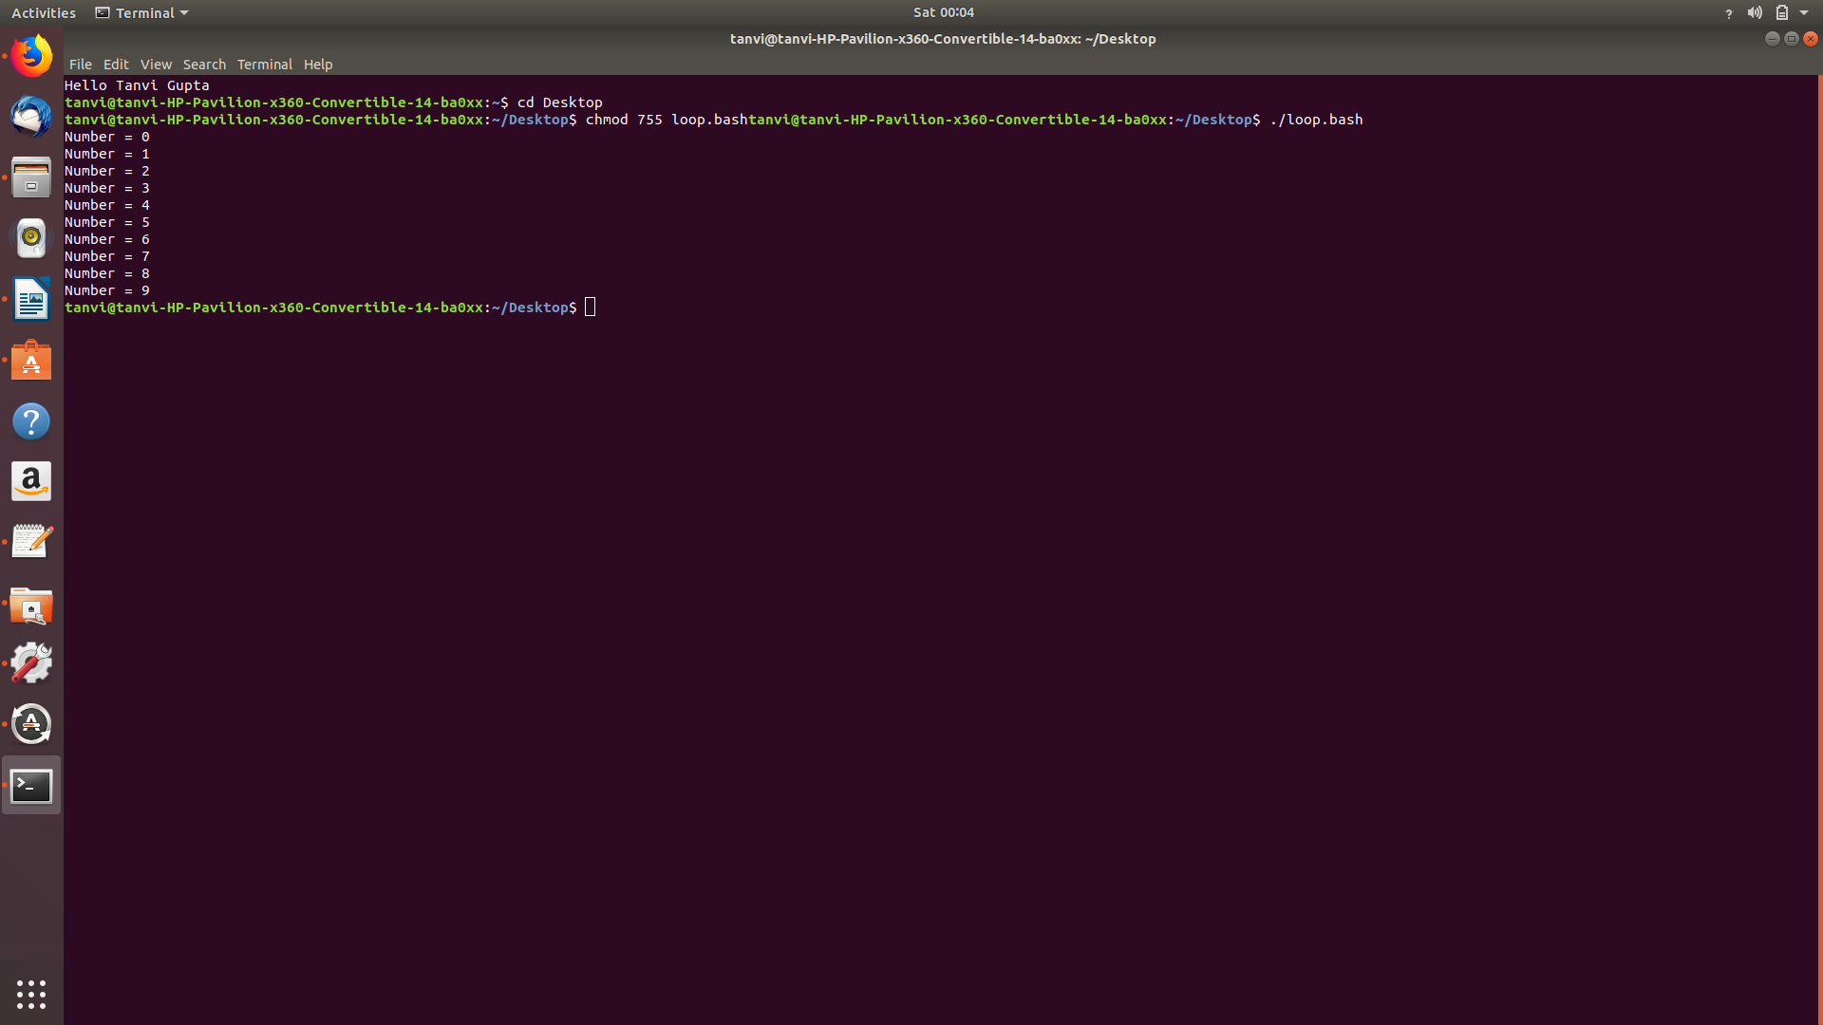

Building a menu

#!/bin/bash

selection=
until [ "$selection" = "0" ]; do
echo "
PROGRAM MENU
1 - Display free disk space
2 - Display free memory

0 - exit program
"
echo -n "Enter selection: "
read selection
echo ""
case $selection in
1 ) df ;;
2 ) free ;;
0 ) exit ;;
* ) echo "Please enter 1, 2, or 0"
esac
done

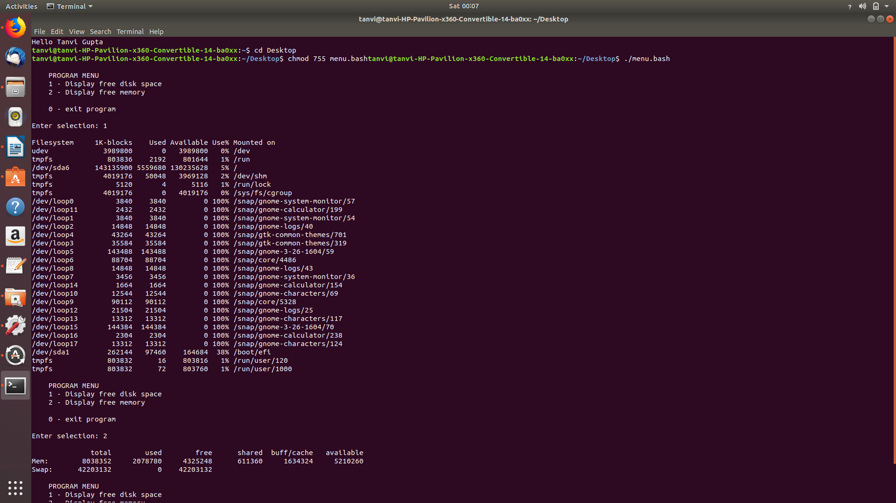

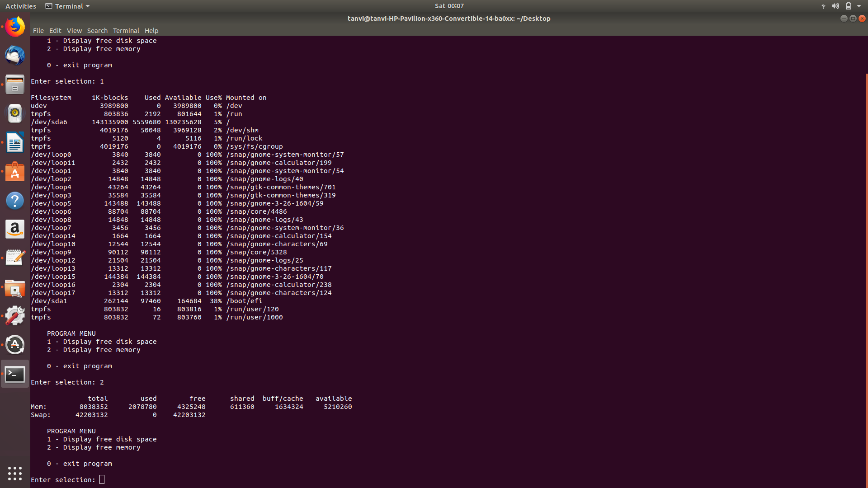

MODULE 12:(SUR_19)

MODULE 13:

Flow Control - Part 3

A simple illustration of for loop

#!/bin/bash
for i in word1 word2 word3; do
echo $i
done

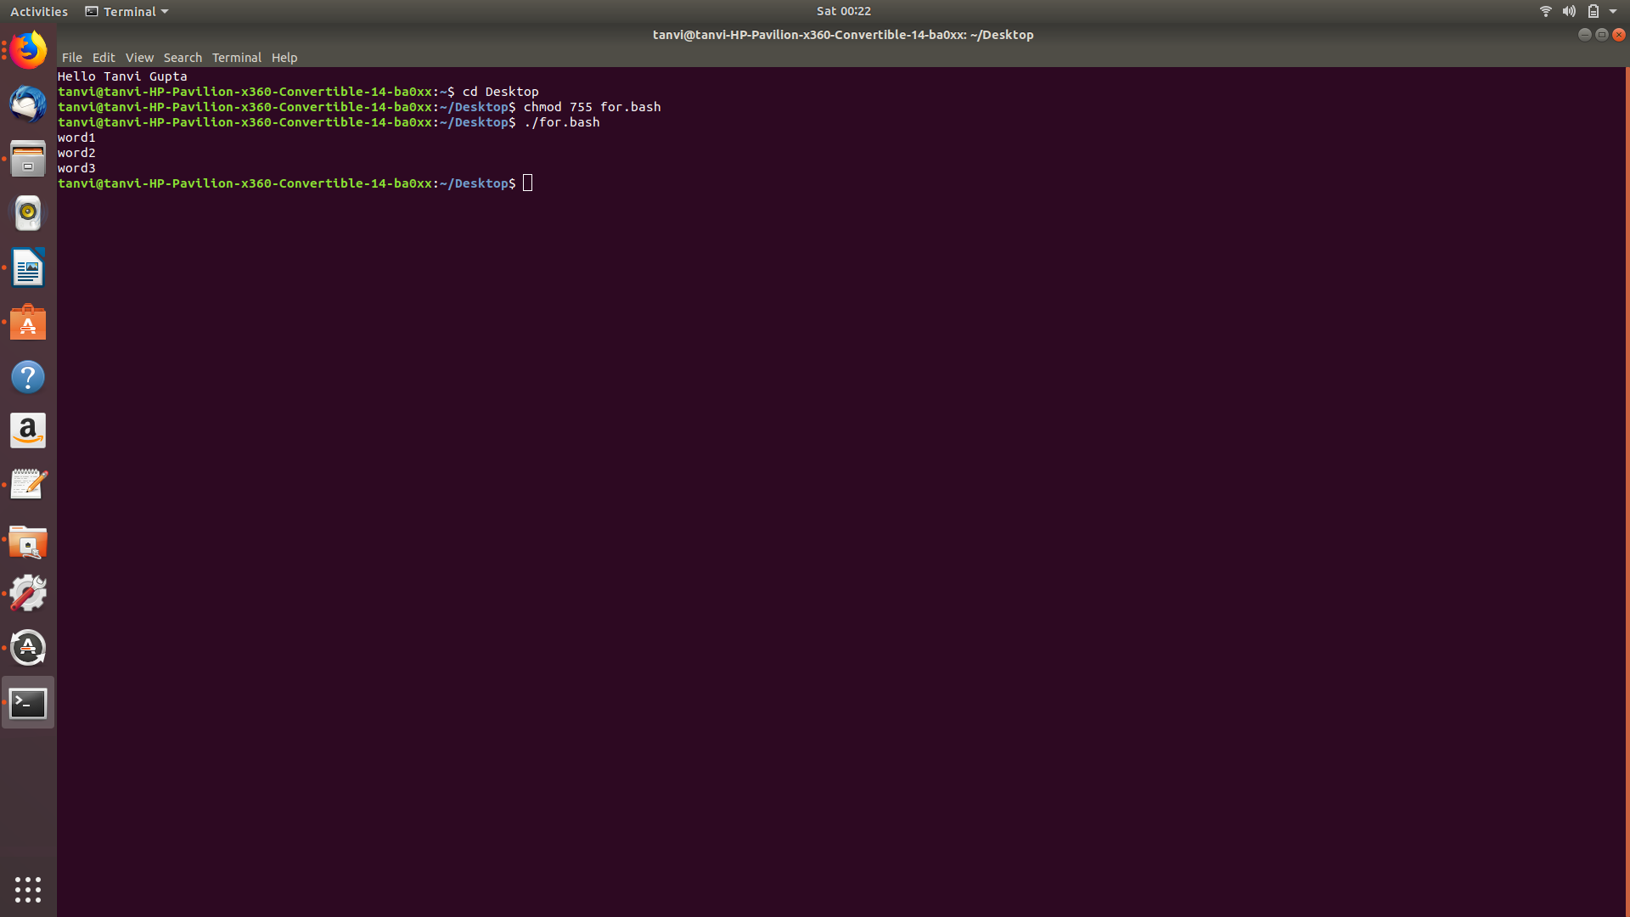

The files in two directories and lists which files in the first directory are missing from the second
#!/bin/bash

# cmp_dir - program to compare two directories

# Check for required arguments
if [ $# -ne 2 ]; then
echo "usage: $0 directory_1 directory_2" 1>&2
exit 1
fi

# Make sure both arguments are directories
if [ ! -d $1 ]; then
echo "$1 is not a directory!" 1>&2
exit 1
fi

if [ ! -d $2 ]; then
echo "$2 is not a directory!" 1>&2
exit 1
fi

# Process each file in directory_1, comparing it to directory_2
missing=0
for filename in $1/*; do
fn=$(basename "$filename")
if [ -f "$filename" ]; then
if [ ! -f "$2/$fn" ]; then
echo "$fn is missing from $2"
missing=$((missing + 1))
fi
fi
done
echo "$missing files missing"

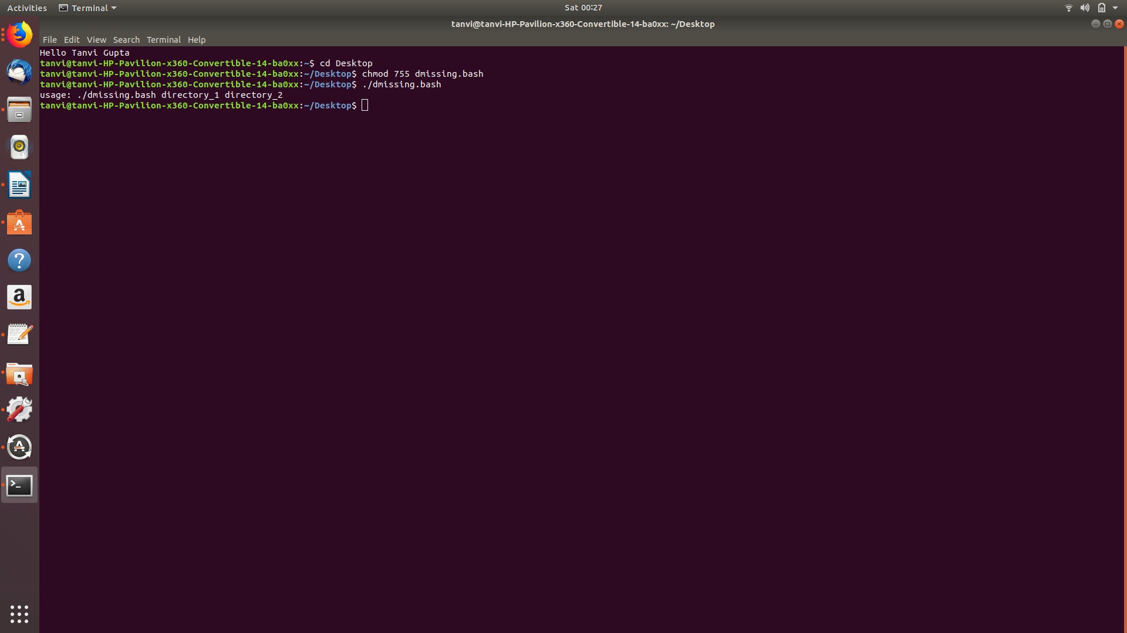

MODULE 14:

Errors and Signals and Traps

Checking the exit status

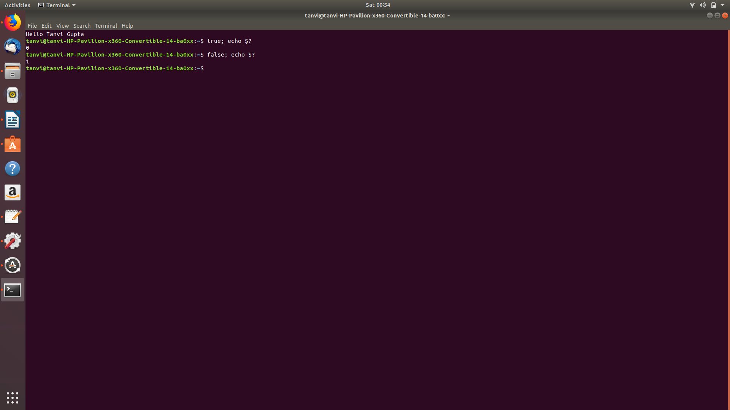

AND And OR Lists

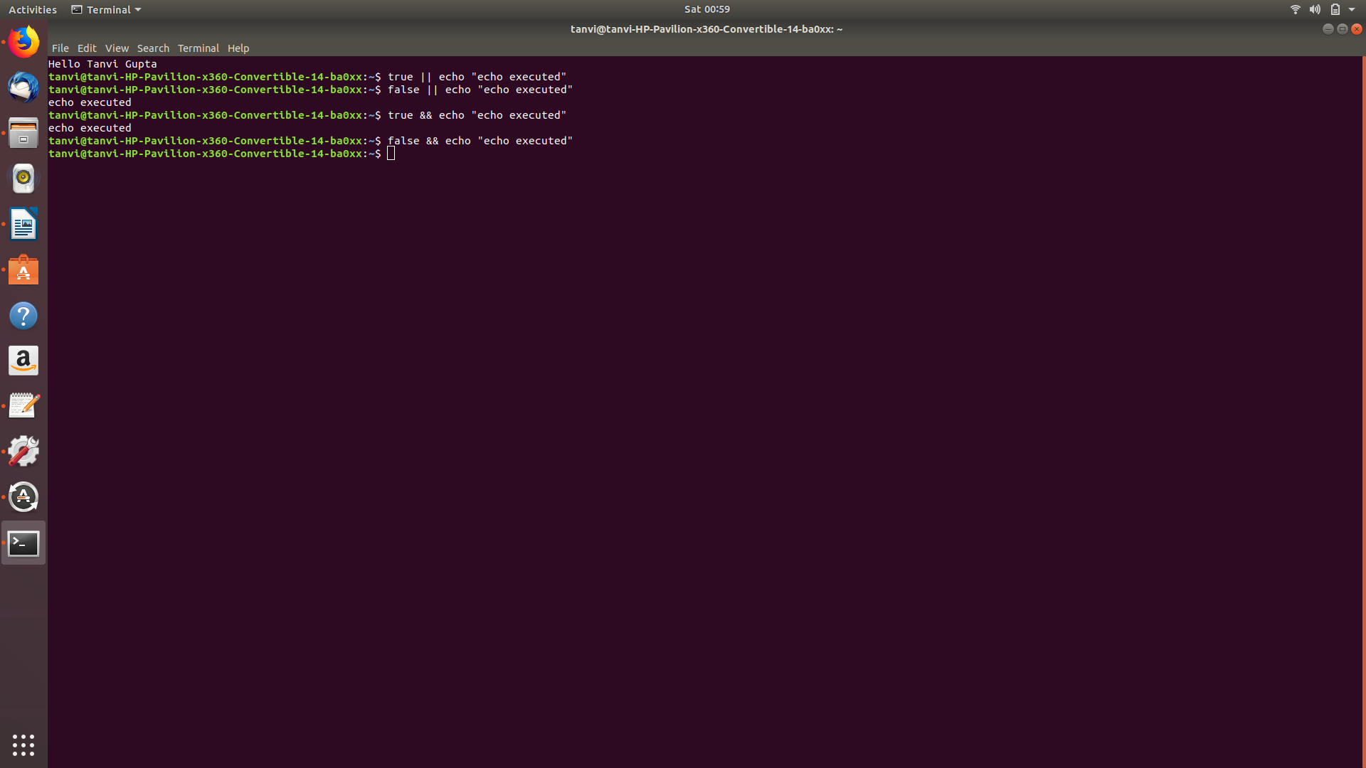

The error exit function

#!/bin/bash

# A slicker error handling routine

# I put a variable in my scripts named PROGNAME which
# holds the name of the program being run. You can get this
# value from the first item on the command line ($0).

PROGNAME=$(basename $0)

error_exit()
{

# ----------------------------------------------------------------
# Function for exit due to fatal program error
# Accepts 1 argument:
# string containing descriptive error message
# ----------------------------------------------------------------

echo "${PROGNAME}: ${1:-"Unknown Error"}" 1>&2
exit 1
}

# Example call of the error_exit function. Note the inclusion
# of the LINENO environment variable. It contains the current
# line number.

echo "Example of error with line number and message"
error_exit "$LINENO: An error has occurred."

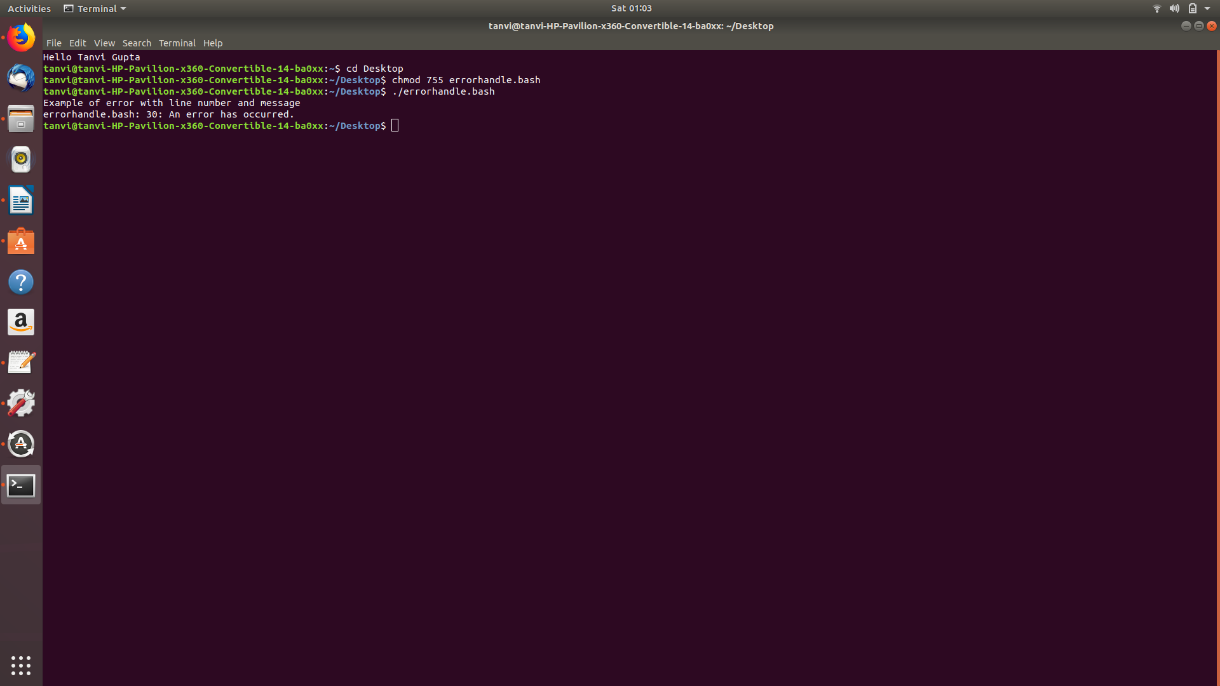

MODULE 15:

Errors are not the only way that a script can terminate unexpectedly. We also have to be concerned with signals. Two examples are shown below:
#!/bin/bash

echo "this script will endlessly loop until you stop it"
while true; do
: # Do nothing
done

#!/bin/bash

# Program to print a text file with headers and footers

TEMP_FILE=/tmp/printfile.txt

pr $1 > $TEMP_FILE

echo -n "Print file? [y/n]: "
read
if [ "$REPLY" = "y" ]; then
lpr $TEMP_FILE
fi

The trap command allows you to execute a command when a signal is received by your script. It works like this:

#!/bin/bash

# Program to print a text file with headers and footers

TEMP_FILE=/tmp/printfile.txt

trap "rm $TEMP_FILE; exit" SIGHUP SIGINT SIGTERM

pr $1 > $TEMP_FILE

echo -n "Print file? [y/n]: "
read
if [ "$REPLY" = "y" ]; then
lpr $TEMP_FILE
fi
rm $TEMP_FILE

Clean up function

#!/bin/bash

# Program to print a text file with headers and footers

# Usage: printfile file

# Create a temporary file name that gives preference
# to the user's local tmp directory and has a name
# that is resistant to "temp race attacks"

if [ -d "~/tmp" ]; then
TEMP_DIR=~/tmp
else
TEMP_DIR=/tmp
fi
TEMP_FILE=$TEMP_DIR/printfile.$$.$RANDOM
PROGNAME=$(basename $0)

usage() {

# Display usage message on standard error
echo "Usage: $PROGNAME file" 1>&2
}

clean_up() {

# Perform program exit housekeeping
# Optionally accepts an exit status
rm -f $TEMP_FILE
exit $1
}

error_exit() {

# Display error message and exit
echo "${PROGNAME}: ${1:-"Unknown Error"}" 1>&2
clean_up 1
}

trap clean_up SIGHUP SIGINT SIGTERM

if [ $# != "1" ]; then
usage
error_exit "one file to print must be specified"
fi
if [ ! -f "$1" ]; then
error_exit "file $1 cannot be read"
fi

pr $1 > $TEMP_FILE || error_exit "cannot format file"

echo -n "Print file? [y/n]: "
read
if [ "$REPLY" = "y" ]; then
lpr $TEMP_FILE || error_exit "cannot print file"
fi
clean_up

